MATH Questions

- Show work/explanation where indicated
1. (4 pts) Solve the inequality x² ≥ 9x and write the solution set in interval notation.
(no explanation required) 1. ______
A. [0, 9]
B. [9, ∞)
C. (–∞, 9] ∪ [0, ∞)
D. (–∞, 0] ∪ [9, ∞)

2. (4 pts) Solve $\frac{x + 6}{x^{2 }- 6x + 8}$≥ 0 and write the solution set in interval notation. 2. ______
(no explanation required)
A. [–6, 2) ∪ (4, ∞)
B. (–∞, –6] ∪ (2, 4)
C. [–6, ∞)
D. (2, 4)

3. (4 pts) For f (x) = x⁴ – 4x² – 9, use the Intermediate Value Theorem to determine which interval must contain a zero of f. (no explanation required) 3. _______
A. Between 0 and 1
B. Between 1 and 2
C. Between 2 and 3
D. Between 3 and 4

4. (4 pts) Translate this sentence about stopping distance into a mathematical equation.
The area A of a regular hexagon is directly proportional to the square of the length s of its sides.

5. (8 pts) Look at the graph of the quadratic function and complete the table. [No explanations required.]
Graph | Fill in the blanks | Equation
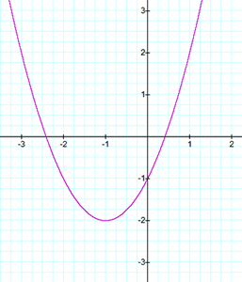 | State the vertex:  ____________  State the range:  _____________  State the interval on which the function is decreasing:  _____________ | The graph represents which of the following equations?  Choice:____  A. y = –x² + 2x – 1  B. y = 2x² + 4x – 1  C. y = x² + 2x – 1  D. y = –2x² – 4x + 1

6. (6 pts) Each graph below represents a polynomial function. Complete the following table.
(no explanation required)
Graph | 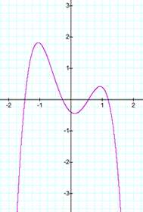Graph A | 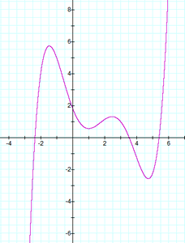  Graph B
Is the degree of the polynomial odd or even? (choose one)
Is the leading coefficient of the polynomial positive or negative? (choose one)
How many real number zeros are there?

7. (12 pts) Let $P\left(x\right)=-0.50x^{3}+{1.75x}^{2}+1.75x-3$
When factored, $P\left(x\right)=-0.5\left(x+\frac{3}{2}\right)\left(x-1\right)\left(x-4\right)$
(a) State the domain.

(b) Which sketch illustrates the end behavior of the polynomial function?
A.  vvvv | B.  vvvv | C.  vvvv | D.  vvvv

Answer: ________

(c) State the y-intercept:

(d) State the real zeros:

(e) State which graph below is the graph of P(x).

GRAPH A. (below) GRAPH B. (below)
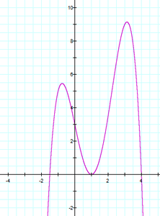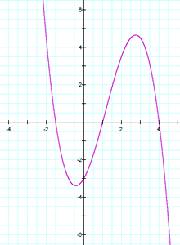
GRAPH C. (below) GRAPH D. (below)
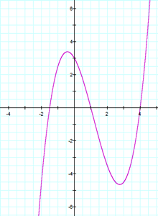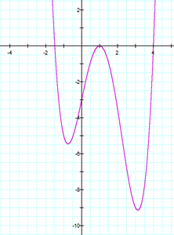

8. (8 pts) Let . (no explanations required)

(a) State the y-intercept.

(b) State the x-intercept(s).

(c) State the vertical asymptote(s).

(d) State the horizontal asymptote.

9. (8 pts) Solve the equation. Check all proposed solutions. Show work in solving and in checking, and state your final conclusion.

10. (8 pts) Which of the following functions is represented by the graph shown below? Explain your answer choice. Be sure to take the asymptotes into account in your explanation.
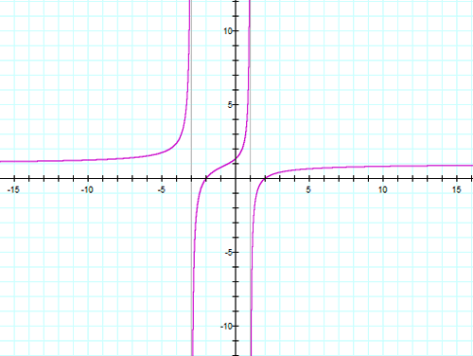

10. _____
A. $f\left(x\right)= \frac{x^{2}- 4 }{x^{2}- 2x - 3}$

B. $f\left(x\right)= \frac{x^{2}- 4 }{x^{2}+ 2x - 3}$

C. $f\left(x\right)= \frac{x }{x^{2}- 2x - 3}$

D. $f\left(x\right)= \frac{x }{x^{2}+ 2x - 3}$

11. (8 pts) For z = 9 + 2i and w = 3 − 5i, find z/w. That is, determine $\frac{9 + 2i}{3 - 5i}$and simplify as much as possible, writing the result in the form a + bi, where a and b are real numbers. Show work.

12. (8 pts) Consider the equation 13x² + 2 = 10x. Find the complex solutions (real and non-real) of the equation, and simplify as much as possible. Show work.

13. (18 pts)
The cost, in dollars, for a company to produce x widgets is given by C(x) = 4200 + 5x for
x ≥ 0, and the price-demand function, in dollars per widget, is p(x) = 32 − 0.03x for 0 ≤ x ≤ 1066.

In Quiz 2, problem #10, we saw that the profit function for this scenario is
P(x) = − 0.03x² + 27x − 4200.

(a) The profit function is a quadratic function and so its graph is a parabola.

Does the parabola open up or down? __________

(b) Find the vertex of the profit function P(x) using algebra. Show algebraic work.

(c) State the maximum profit and the number of widgets which yield that maximum profit:

The maximum profit is _______________ when ____________ widgets are produced and sold.

(d) Determine the price to charge per widget in order to maximize profit.

(e) Find and interpret the break-even points. Show algebraic work.

